A proposal to save the East Paddock and turn it into a new public park for west Cambridge.
The last remaining large green space on the West Cambridge Site is threatened by development. Comprising less than 5% of the site, the East Paddock is shown as the meadow image below. This proposal makes the case to spare the East Paddock from development and turn it into a public park – about one third the size of Parker’s Piece.
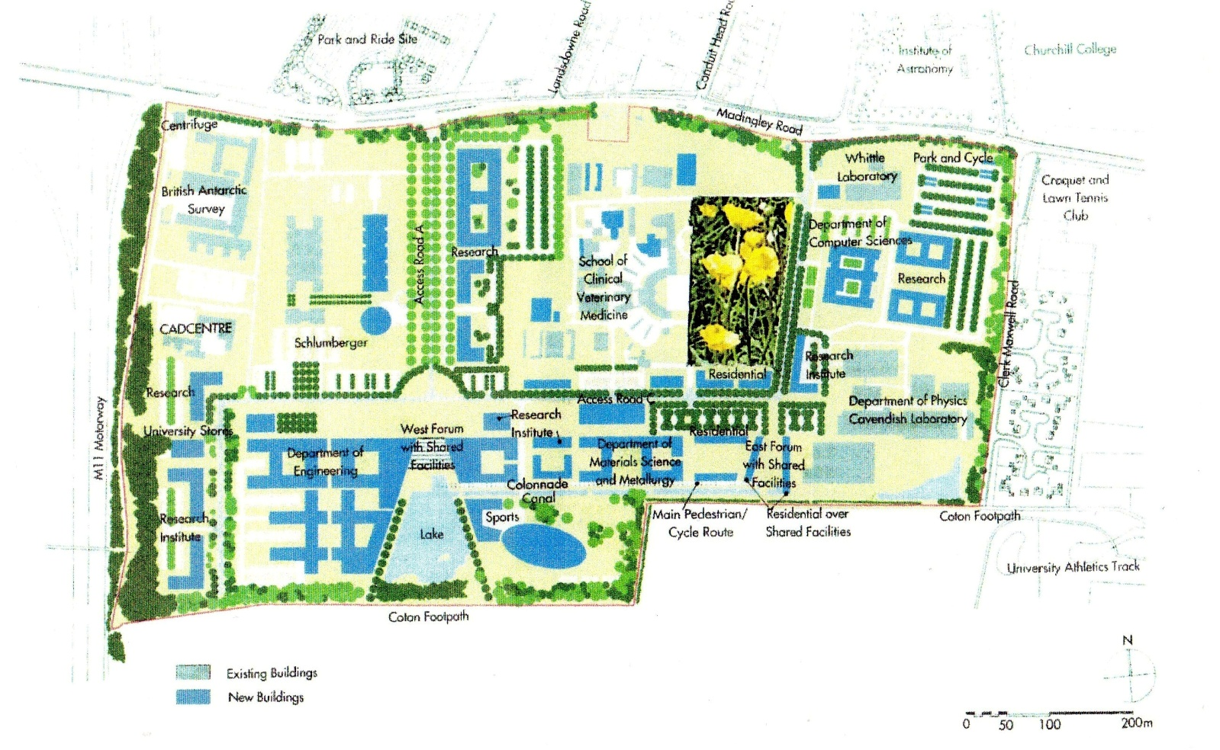
The East Paddock is an ancient meadow on the University of Cambridge West Cambridge Site, lying between the Veterinary School and J J Thompson Avenue. Less than 5% of the total area of the West Cambridge Site, it is the last remaining large green space not yet approved for development.
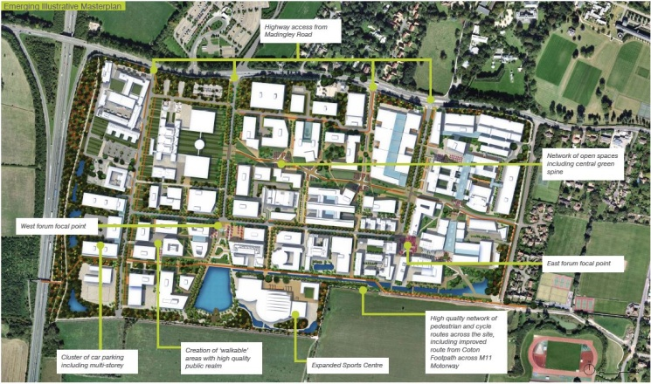
Illustrative master plan, Cambridge University Reporter, 21.5.15.
An illustrative revised master plan, which has been published by Cambridge University but not yet submitted to or approved by the City Council, is shown to the left. It proposes that the whole site (including the East Paddock) be built over, leaving no substantial area of green space on the 165 acre West Cambridge Site.
We suggest that without a substantial green space the West Cambridge site would amount to an industrial estate – not a high quality academic campus of which the University and the city can be proud. We propose instead that the East Paddock should be spared from development, and should be turned into a new public park which would be about one third the size of Parker’s Piece. Our arguments are:
a. The character of Cambridge. It is a defining and much valued characteristic of historic Cambridge that dense development alternates with frequent and substantial public open spaces such as Jesus Green, Parker’s Piece, and Lammas Land.
b. The example of the North West Cambridge Site. This Cambridge precedent has been admirably followed in the University’s excellent master plan for the North West Cambridge site (north of Madingley Road) which incorporates a large public park.
c. Amenity. Turning the East Paddock into a public open space would provide a welcome amenity for the many thousands who will be working or living on the West Cambridge site, and for the local community.
d. Sense of place. A park formed from the East Paddock would provide a green lung at the heart of the West Cambridge Site. It would create a sense of place, and would uplift the quality of the whole development.
d. Existing policy. The existing 2004 approved master plan states that ‘the major area of paddocks to the front of the Veterinary School [the East Paddock] continues to provide an open area as a setting for the buildings’. Also the draft Cambridge Local Plan 2014 states that proposals should ‘create clearly defined public and private amenity spaces that are designed to be inclusive, usable, safe and enjoyable’ (Policy 56f).
e. Feasibility. As the East Paddock comprises less than 5% of the whole West Cambridge Site, it should be possible to re-arrange development into the other 95% of the site.
f. A historic opportunity. The preservation of the East Paddock is a historic opportunity because once green space is built over it can never be recovered. The threat to the East Paddock is imminent. Exploratory archaeological excavations, required prior to development, are already under way.
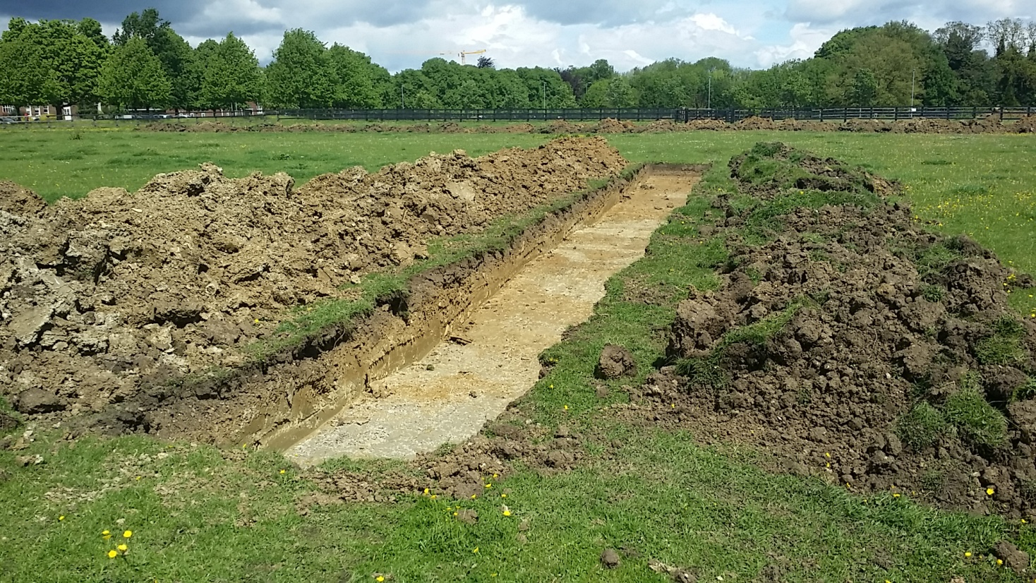
Exploratory archaeological excavations, 21.5.15

This proposal is put forward by a group of Cambridge residents who believe extensions to the city should achieve the same high quality as its historic core. For further information, and to express support for this proposal, please contact:
Alex Reid, 27 Millington Road, Cambridge CB3 9HW. Tel: 07748 654008.
Email: aalreid@gmail.com
Website: www.eastpaddock.com 28.5.15

The alternatives are:
An industrial park
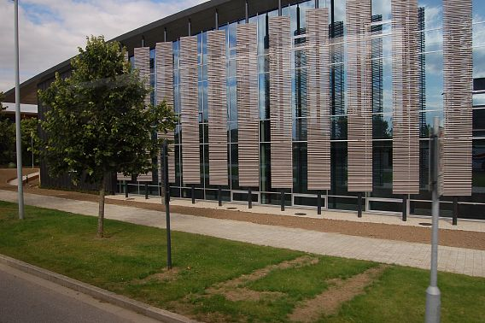
Physics for Medicine Building, West Cambridge Site
Or a campus around a real park
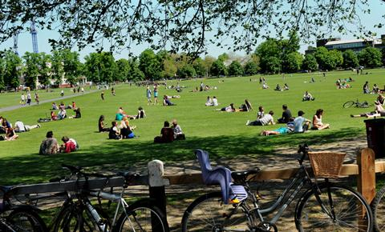
Parker’s Piece

